|  |
| --- |
| COMP710 Individual Game Project |
| Abysswalker |
| By Duane Belleza |

|  |
| --- |
| Student ID: 22168617  3-5-2025 |

Table of Contents

Technical Overview 2

System Architecture 2

Key Algorithms & Logic 2

Technical Implementation 2

Development Standards 2

Asset Management 2

## **Technical Overview**

## Key Algorithms & Logic

### Stamina Regen

* Regens stamina at 10 units per second when player is not performing certain actions that use stamina (attacking, rolling or jumping)
* Stamina will only be consumed when doing:
  + Jump: 15 stamina
  + Attack: 10 stamina
  + Roll: 30 stamina
* Stamina cannot exceed maximum capacity (100 base)

### Movement Physics

* Horizontal movement affected by turning speed factor
* Vertical movement uses gravity acceleration
* Ground collision which prevents players falling through floor
* Momentum preserved when doing rolls or when getting knock backed.

### Player State Machine

* Manages transitions between player states
* Each state will have their own specific animation tied to the state name, i.e.:
  + Can only attack when on the ground
  + Can only jump when on the ground
  + Cannot jump when already jumping

### Animation System

* Sprite animations are tied to player states
* Animation completion will trigger state transitions, i.e.:
  + Attack animations complete -> go back to idle
  + Roll animation complete -> return to idle or whatever the player was doing last
  + Turn animation complete -> player faces new direction

### Death/Resurrection

* Death occurs if the player’s health reaches 0
* Death animation plays and player won’t be able to change states or move
* Resurrection system will allow the player to be revived (Needs Abyssal Essence)
  + Fully restores health and stamina
  + Gains invincibility for a couple seconds
  + Returns to idle state and resets position on the ground.

## Flowchart and UML Class Diagrams

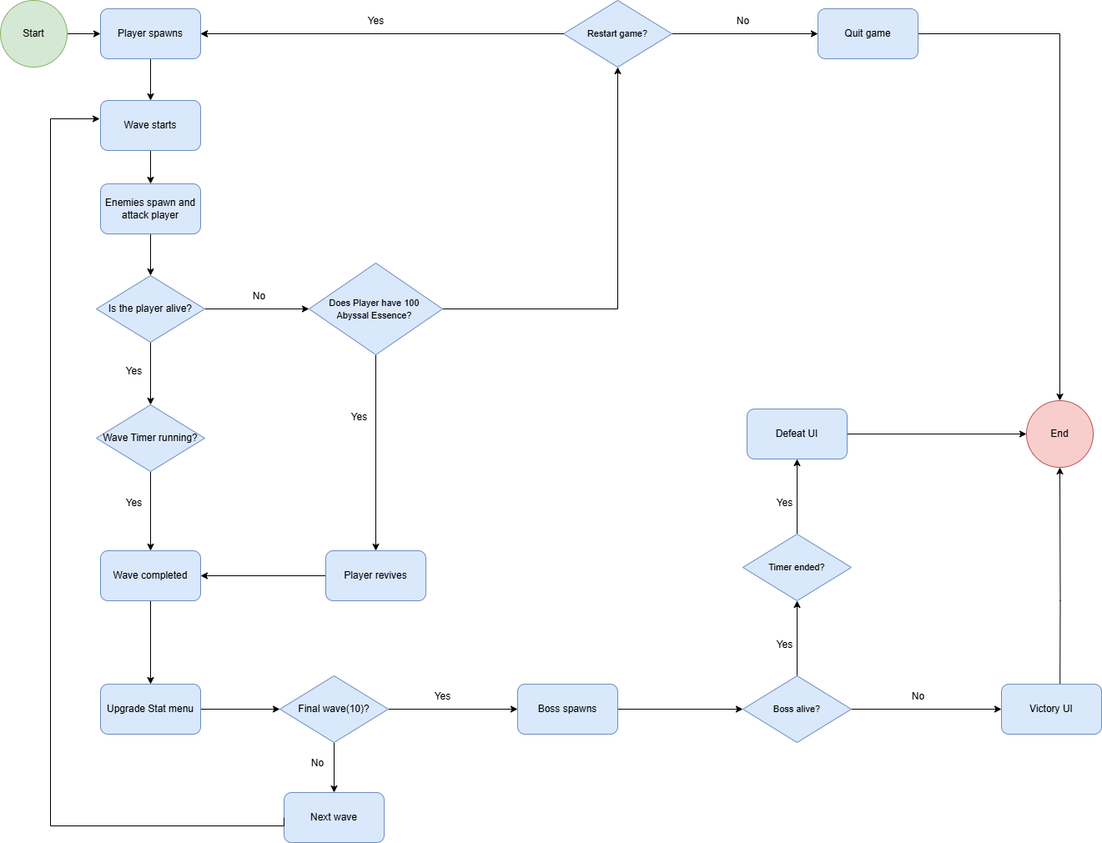Flowchart:

## Class Diagrams

Player:

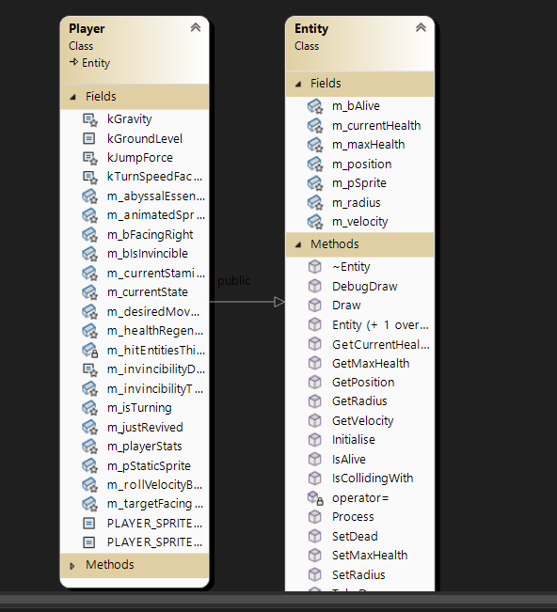

Enemies:

Scenes

### Cheats

Abysswalker will have some cheats implemented with the use of ImGui

* Debug Menu
  + The menu can be accessed with the ‘`’
  + It will display the ImGui Menu
* God Mode
  + Key is F1
  + Players cannot die
* One Shot Enemies
  + Key is F2
  + Players can kill anything in 1 hit
* Inf Stamina
  + Key is F3
  + Players can attack and roll forever
* Skip to last wave
  + Key is F4
  + Players will be able to skip all the way to the last boss

## Development Standards

* Coding standards
  + Abysswalker will be written in C++
  + Abysswalker will have appropriate comments on sections of the code
* Naming Schemes
  + Member variables will be prefixed with the ‘m_’
  + Local variables will be using camelCase
  + Will be using PascalCase for the .h and .cpp file names
  + Class names will be using PascalCase
  + Enum names will be using PascalCase
  + Enum members will be using UPPER_SNAKE_CASE
* Relevant File formats
  + Game assets for players and enemies will be stored as .png files
  + Game audio will be sored as .wav or .ogg

## Acceptance Test Plan

To see if Abysswalker is completed with its features or not, look at the following acceptance tests to make sure the game passes all of them.

1. The game launches without error.
2. The player can move using ‘A’ ‘D’ ‘Space’ and ‘Q’, or the DPAD on the controller.
3. The enemies should spawn on either side of the screen in waves.
4. The player can attack and dodge enemies with the use of the ‘J’ Key to attack or ‘Q’ Key to dodge.
5. The player will run out of stamina if jumping, rolling and attacking too much.
6. The game should have all necessary sprites, and the player should be able to see them moving.
7. The player should also be able to upgrade their stats at the end of each wave.
8. Players should also be getting Abyssal Essence.
9. Debug menu should be accessible with ‘`’ (The button on the right of ‘1’ Key) (Grave Accent Key)
10. All sprites should have the appropriate audio.